Prac 3: Data visualisation
SOST10142/20142 Applied Statistics for Social Scientists
2024-02-13
Contents
1 Set your current path 2
2 Learning outcome: 2
3 Prep 2
4 Introducing birthweight data and aims 4
5 Read in data and generate the low bwt dummy 4
6 Treat outliers 5
7 Select and identify variable types 8
8 Group summary statistics 8
9 Visualising Continuous Variables: 9
9.1 Histogram : 9
9.2 Histogram : Extension 12
9.3 Density plot: 13
9.4 Density plot: Extension 13
9.5 Boxplot: 16
9.6 Boxplot: Extension 16
9.7 Scatterplot: 17
9.8 Scatterplot: Extension 18
9.9 Scatterplot: Extension using faceting 20
10 Visualising Categorical Variables: Use Barplots 21
10.1 One categorical var 21
10.2 Two categorical vars 22
10.2.1 Clustered barchart : position = “dodge” 22
10.2.2 Stacked barchart 24
11 Save plots 24
12 Your task 25

1 Set your current path
Run the line below to set the path. Ensure all your files are located here. Customise the path as necessary. Then, check.
rm(list = ls()) # Remove objects
setwd("P:/R_AST")
getwd()

2 Learning outcome:
By the end of the practical, students will be able to understand and use the structure of ggplot for plotting. To be specific:
- Identify outliers and treat them appropriately
- Use aes to specify x-axis and y-axis variables
- Choose appropriate graph types among
geom_histogram(),
geom_density(),
geom_boxplot(),
geom_point()
geom_bar() # categorical variables
- Use facet_wrap to investigate bivariate distributions and beyond
- Combine multiple graphs using grid.arrange() and save images

Tutors may skip section 10 visualising categorical variables if the time does not permit. This section is a minor extension of Practical 2 and students can follow instructions independently as necessary.

3 Prep
We first install several packages. As this can be done once, please skip if you have already installed.
# install.packages("haven") # To read .dta data
# install.packages("tidyverse") # modern data manipulation
install.packages("ggplot2") # grapahics
# install.packages("tableone") # descriptive statistics
Then, load these packages using library().
# Load packages (MUST LOAD EVERY SESSION!)
library("haven") # To read .dta data file
library("tidyverse") # data manipulation
library("ggplot2") # grapahics
library("gridExtra") # Combine graphs
library("janitor") # cross-tabulation
library("psych") # descriptive statistics
theme_set(theme_bw()) # set grapahics theme

4 Introducing birthweight data and aims
R and user-written packages offers ample example datasets for users. We use UseR package’s babies dataset. The dataset stems from Child Health and Development Studies (CHDS). The study collected data from women who received prenatal care in the Kaiser Foundation Health Plan in the San Francisco–East Bay area and delivered at any one of the Kaiser hospitals in northern California during 1960 and 1967. Over 15,000 families participated in the CHDS. The CHDS is still ongoing (https://www.phi.org/our-work/programs/child-health-and-development-studies/). You may find some online resources on a similar topic including here (https://www.stat.berkeley.edu/users/nolan/IntroRPgm/chap-Graphics.html#sec:ggplot). Please feel free to refer to them to maximise your learning on data visualisation using the ggplot2 package as necessary.

5 Read in data and generate the low bwt dummy
Let’s read in the csv data.
b <- read.csv("babies_25vars.csv")
Next, we generate a low birthweight dummy (Low birthweight defined as less than 2.5kg, or 5 pounds 8 ounces).
b <- b %>% mutate(low_bwt = ifelse(bkg < 2.5, 1, 2) )
b %>% tabyl(low_bwt)
## low_bwt n percent
## 1 63 0.05097087
## 2 1173 0.94902913
Now, factorise the dummy variable.
b$fct_lowbwt <- factor(b$low_bwt,
labels = c("Yes", "No"))
Carry out checks to ensure recoding and factorisation was performed as intended. What is the proportion of babies who are considered low birthweight?
# b %>% tabyl(bkg, low_bwt)
b %>% tabyl(fct_lowbwt, low_bwt)
## fct_lowbwt 1 2
## Yes 63 0
## No 0 1173
Please note that in factorisation, we need to organise low birthweight as Yes then No, since in graphs, we expect to see the Yes response first, rather than No. Thus, we need to assign corresponding numeric values in the correct order as Yes = 1, No = 2. This numeric values are used to give the correct order of the categories.
TIP: If we code as Yes = 1, No = 0, the second category, No, is printed first before Yes, which can be counter-intuitive. This is because R sorts numeric values in ascending order and merely prints labels corresponding to the numeric code. As such, care needs to be taken to avoid any conflicts.
prac <- b %>% mutate(low_bwt = ifelse(bkg > 2.5, 0, 1) )
prac %>% tabyl(low_bwt)
low_bwt n percent
0 1173 0.94902913 # No
1 63 0.05097087 # Yes

6 Treat outliers
We can visualise (mothers’) age to inspect any outliers.
hist(b$age)
boxplot(b$age)
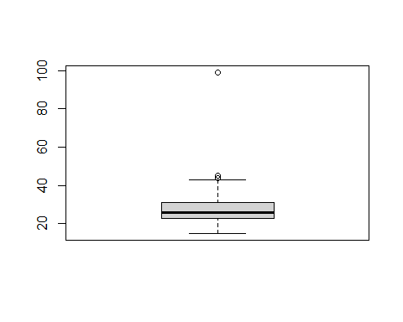
summary(b$age)
## Min. 1st Qu. Median Mean 3rd Qu. Max.
## 15.00 23.00 26.00 27.37 31.00 99.00
sd(b$age)
## [1] 6.456992
We can print mean and SD together using describe using psych package. We add fast to print the compact table. Also, the whole dataset can be used instead of one variable. Test using describe(b) and see the difference.
describe(b$age, fast = TRUE)
## vars n mean sd min max range se
## X1 1 1236 27.37 6.46 15 99 84 0.18
Inspect the output and calculate the age where 99.7% of the mothers’ age would lie. Hint: Recall the empirical rule concerning normal distribution (the 68-95-99.7 rule). 0.18x3=0.54 +27.37= 27.91 27.37-0.54=26.83 26.83-27.91

If you apply the empirical rule, any values above 46.38 years of age can be considered outliers. We remove such cases. As this is an important step, we save in a new object.
bb <- b %>% filter(age < 48)
Now, run a descriptive statistics table of age and visualise it without outliers.

Why do we still see outliers in the boxplot? This is because boxplot’s outliers are defined by 1.5*IQR, which is more conservative than z-score method we used. As boxplots tend to pick up rather mild values as outliers, we can acknowledge this difference and move on to the next step.

7 Select and identify variable types
As we are primarily concerned about the relationship between the mother’s smoking status during pregnancy and the baby’s birthweight, we restrict our analyses focussing on the following variables:
Continuous Categorical
---------- ----------
birthweight smoking status,
age low birthweight
The cleaned dataset with key variables are saved in the dataset, baby.
baby <- bb %>%
select(id, bkg, age, height,
weight, starts_with("fct") )
We will use this baby dataset for visualisation. Note R data object is written in a file and is loaded subsequently. You can use the following code to load a cleaned dataset stored in R format, rather than in csv or dta, for visualization, as necessary.
Let’s remove id and produce a descriptive statistics table.
babydesc <- baby %>% select(-id)
print(CreateTableOne(data = babydesc),
showAllLevels = TRUE )

8 Group summary statistics
We can use psych packages’s descriptive if we are mainly interested in continuous variables.
describe(babydesc[, 1:4], fast = TRUE)
We may pose a question, “Is there a birthweight difference by smoking status?”. To answer this, we compute summary statistics of birthweight by smoking status. For group summary statistics, specify the grouping variable after comma.
# GROUP SUMMARY STATS: bkg by a categorical var
describeBy(babydesc$bkg, babydesc$fct_smoke, fast = T)
What do you conclude? On average mothers who have never smoked have an increased baby weight of 0.26
Visualisation strategy : Using the compact dataset, baby, We will carry out visualisation using one variable, then add another variable to inspect univariate and bivariate distributions, respectively. Recall the basic structure of R graphics:
ggplot(data, aes(x = var1, y = var2))
We will use the above code repeatedly in R graphs. To explore further, we’ll use additional options in aes:
colour = , fill = , shape = , alpha =
Note alpha enables transparent plotting when two graphs are overlapping.

9 Visualising Continuous Variables:
We will use the following graphs to visualise a continuous variable.
Histogram  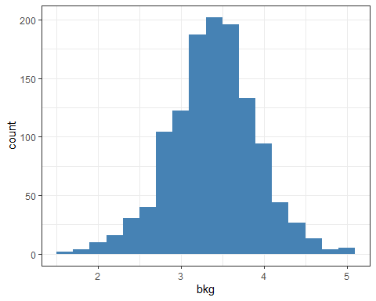 | Density plot  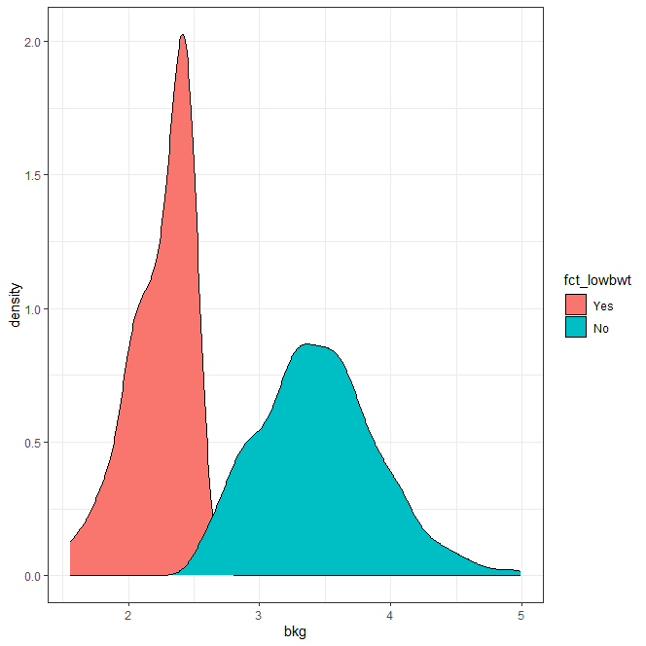
Boxplot  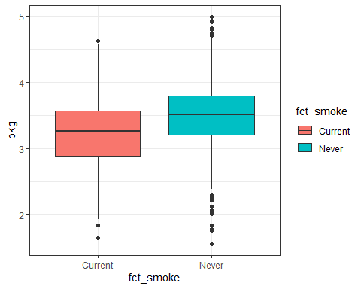 | Scatterplot  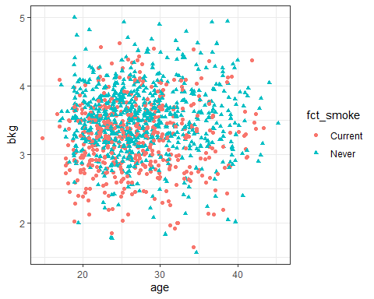

Let’s visualise birthweight and extend the visualisation by adding smoking status.

9.1 Histogram :
Can you see any potential outliers of birthweight? Does the shape follow normal distribution?
ggplot(data = baby, aes(x = bkg)) +
geom_histogram()
## `stat_bin()` using `bins = 30`. Pick better value with `binwidth`.
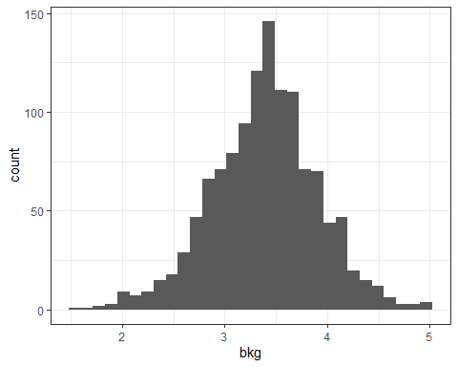
Let’s experiment with aesthetics of histogram. We change the binwidths to 0.2. Can you try with binwidth = 1? We can add colour to be filled. Ensure you use quotes ". Experiment with fill = "darkgreen".
ggplot(data = baby, aes(x = bkg)) +
geom_histogram(binwidth = 0.2)
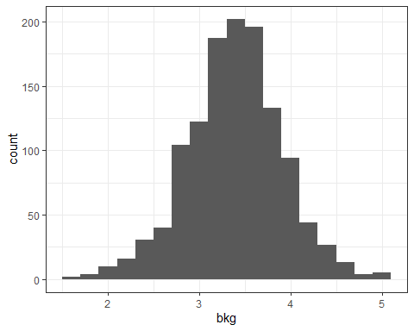
ggplot(data = baby, aes(x = bkg)) +
geom_histogram(binwidth = 0.2, fill = "steelblue")
The fill option should not be confused with colour option, which merely applies the outline colour.
ggplot(data = baby, aes(x = bkg)) +
geom_histogram(colour = "steelblue")
## `stat_bin()` using `bins = 30`. Pick better value with `binwidth`.

9.2 Histogram : Extension
We now extend our exploration to bivariate distributions. We define fill or colour options in aes by using a categorical variable, fct_lowbwt. This time, we do not use quotes as we specify variables.
ggplot(data = baby, aes(x = bkg, fill = fct_lowbwt)) +
geom_histogram()
## `stat_bin()` using `bins = 30`. Pick better value with `binwidth`.
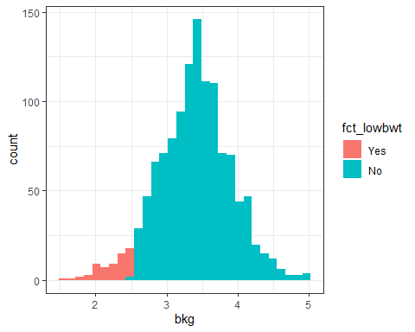
Test with the colour option. Is it useful?
Depending on the aim, presenting graphs side by side can be more helpful to illustrate the story. The option, facet_wrap allows to do so.
ggplot(baby, aes(x = bkg)) +
geom_histogram() +
facet_wrap (~fct_lowbwt)
## `stat_bin()` using `bins = 30`. Pick better value with `binwidth`.
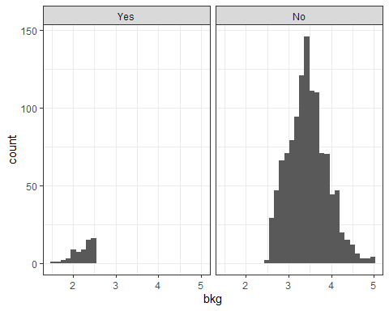

9.3 Density plot:
Instead of histogram, we can also use the density plot to inspect distributions of continuous measures. Often called a kernel density plot, density plot illustrates the smoothed distribution of continuous variables. Density plots can represent distributions more clearly and make the differences between categories of the second variable clearer.
ggplot(baby, aes(x = bkg)) +
geom_density()
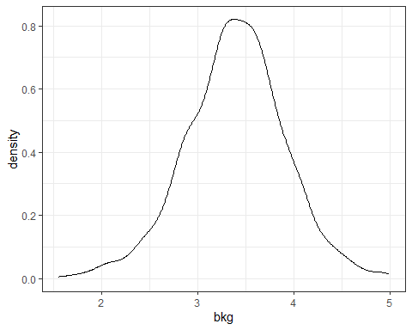

9.4 Density plot: Extension
Next, We add fct_lowbwt using fill option. What pattern can you observe?
ggplot(data = baby, aes(x = bkg, fill = fct_lowbwt)) +
geom_density()
## `stat_bin()` using `bins = 30`. Pick better value with `binwidth`.
Notice that some portion of density plot is hidden. We specify alpha as 0.2 to change transparency settings. The smaller alpha values represent lighter shades of colour. Let’s save and combine the two density plots before printing in one graph.

d1 <- ggplot(baby, aes(x = bkg, fill = fct_lowbwt)) +
geom_density()
d2 <- ggplot(baby,
aes(x = bkg, fill = fct_lowbwt, alpha = 0.2)) +
geom_density()
grid.arrange(d1, d2, ncol = 2, nrow = 1)
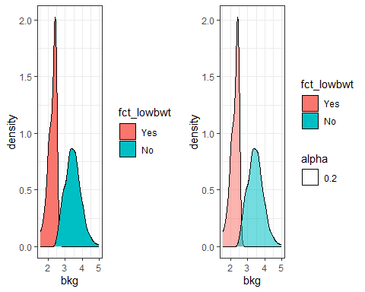
Can you further extend the visualisation by smoking status plotted side by side? Add the following code. Does the pattern change?
facet_wrap(~fct_smoke)
One can also remove alpha legend by specifying guides(alpha = "none").
ggplot(baby,
aes(x = bkg, fill = fct_lowbwt, alpha = 0.2)) +
geom_density() +
facet_wrap (~fct_smoke) + guides(alpha = "none")

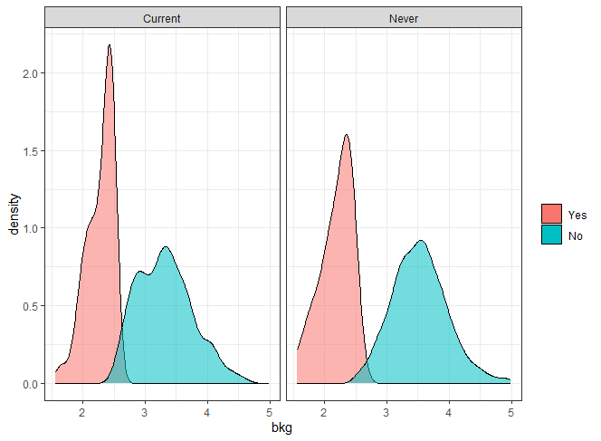

9.5 Boxplot:
Another simple way to visualise the continuous measures’ distributions is utilising boxplots. Boxplots prove five summary statistics including minimum, maximum, median, 25th and 75th percentile, displaying the inter-quartile range. Recall, we saw the utility of boxplots already while detecting outliers.
ggplot(data = baby, aes(y = bkg)) +
geom_boxplot()
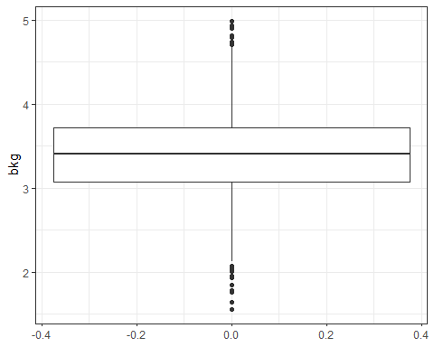

9.6 Boxplot: Extension
We add a grouping (categorical) variable, fct_smoke in x axis.
ggplot(data = baby, aes(x = fct_smoke, y = bkg)) +
geom_boxplot()
Let’s add frills to make it more aesthecially-pleasing.
ggplot(data = baby,
aes(x = fct_smoke, y = bkg, fill = fct_smoke)) +
geom_boxplot()

9.7 Scatterplot:
Unlike histogram, density plot, and boxplot, scatterplots require two continuous variables as it depicts the linear relationship between the two continuous measures.
ggplot(data = baby, aes(x = age, y = bkg)) +
geom_point()
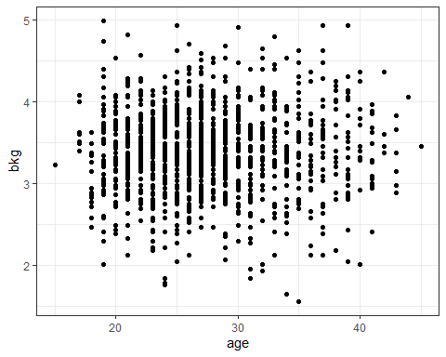
We can improve the appearance by moving the data points slightly so they are not overlapping. The option, position = "jitter" does this.
ggplot(data = baby, aes(x = age, y = bkg)) +
geom_point(position = "jitter")
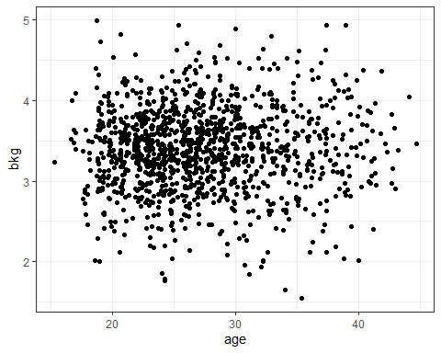
You may further add alpha option for a better presentation.

9.8 Scatterplot: Extension
We add a third variable as a grouping (categorical) variable, fct_smoke in colour option.
ggplot(data = baby,
aes(x = age, y = bkg, color = fct_smoke)) +
geom_point(position = "jitter")
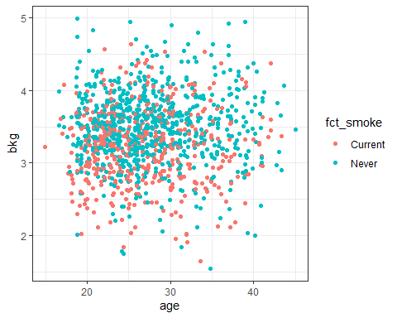

Is there a discernible linear relationship? Let’s control the colour with the scale_colour_manual() argument.
ggplot(data = baby,
aes(x = age, y = bkg, colour = fct_smoke)) +
geom_point(position = "jitter", alpha = 0.8) +
scale_colour_manual(values = c("steelblue", "red"))
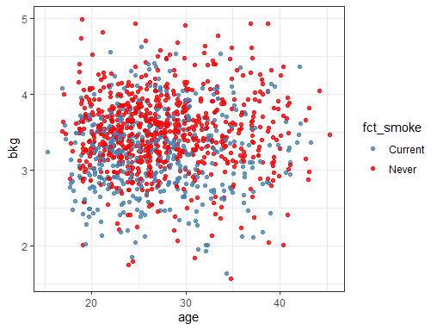
Discussing the full extent of options is beyond the scope but you may test with darkblue, blue, green, and orange, for example.
Alternatively, you may consider shape option.
ggplot(data = baby,
aes(x = age, y = bkg, shape = fct_smoke)) +
geom_point(position = "jitter")
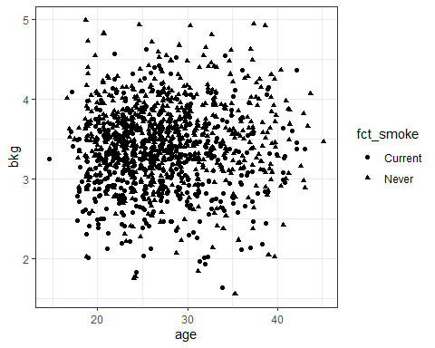
As the default prints all in black, we also include colour. Note that you could add yet another variable to colour argument. Test this yourself.
ggplot(data = baby,
aes(x = age, y = bkg,
shape = fct_smoke, colour = fct_smoke)) +
geom_point(position = "jitter")

9.9 Scatterplot: Extension using faceting
Plotting side by side is another way. Recall facet_wrap option.
ggplot(data = baby,
aes(x = age, y = bkg)) +
geom_point(position = "jitter") +
facet_wrap (~fct_smoke)
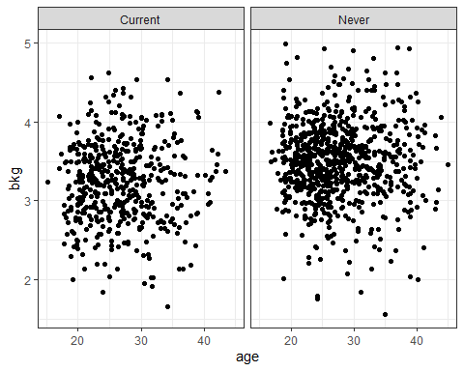
We can plot using four variables using facet_grid (fct_lowbwt~fct_smoke). This produces a side by side graph with four panels in a grid.
ggplot(data = baby,
aes(x = age, y = bkg)) +
geom_point(position = "jitter") +
facet_grid (fct_lowbwt~fct_smoke)
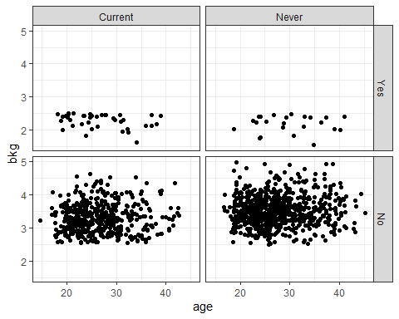

10 Visualising Categorical Variables: Use Barplots
For categorical variables, the distributions are best shown in relative frequency, rather than in raw counts. As such, we will save the table containing relative frequency and use this information while plotting barcharts. The preliminary steps for barplots are recoding and factorising variables. This is to allow printing a clear meaningful label (not 0 or 1) for each category. Consult Practical 2 for the review of these preliminary steps. This also pre-empts decluttering in your R code and helps maintain readability of your syntax.

10.1 One categorical var
The simplest form would be ggplot(data, aes(x = var1)) + geom_bar(). To report distributions in proportions (relative frequency), we obtain a frequency table and use the proportion in ggplot argument. We need stat = "identity" option to achieve this.
a <- baby %>% tabyl(fct_lowbwt)
p1 <- ggplot(data = a,
aes(x = fct_lowbwt, y = percent*100)) +
geom_bar(stat = "identity")

10.2 Two categorical vars
Clustered barchart  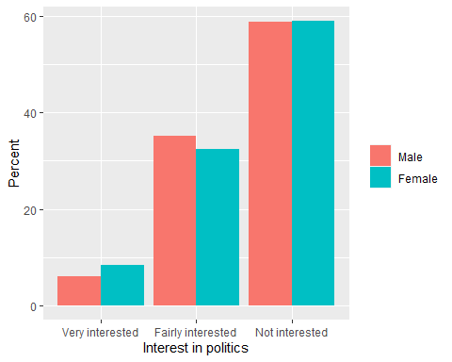 | Stacked barchart  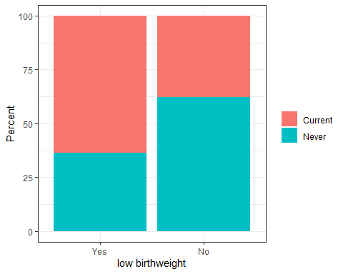
With two categorical variables, the procedure gets slightly involved. We first need to compute percentage of low birth weight by each smoking status category.
fct_lowbwt fct_smoke count perc
1 Yes Current 40 63.5
2 Yes Never 23 36.5
3 No Current 443 37.8
4 No Never 728 62.2
As the tabyl function producing a crosstab prints in format not helpful for barcharts, we use group_by and summarise functions.
aaa <- baby %>%
group_by (fct_lowbwt, fct_smoke) %>%
summarise (count = n() ) %>%
mutate(perc = (count/sum(count))*100)
## `summarise()` has grouped output by 'fct_lowbwt'. You can override using the
## `.groups` argument.
aaa
## # A tibble: 4 × 4
## # Groups: fct_lowbwt [2]
## fct_lowbwt fct_smoke count perc
## <fct> <chr> <int> <dbl>
## 1 Yes Current 40 63.5
## 2 Yes Never 23 36.5
## 3 No Current 443 37.8
## 4 No Never 728 62.2

10.2.1 Clustered barchart : position = “dodge”
We define x as the outcome variable, fct_lowbwt. The cluster is indicated by fill = fct_smoke argument. In geom_bar(), we specify position = "dodge" to put the bars side by side for each x-axis category.
ggplot(aaa,
aes(x = fct_lowbwt, y = perc, fill = fct_smoke)) +
geom_bar(stat = "identity", position = "dodge")
Let’s fine-tune the graph by adjusting bar width and adding labels. For the clustering variable, we instruct R to print the legend label as Smoking status to be more intuitive for readers.
ggplot(aaa,
aes(x = fct_lowbwt, y = perc, fill = fct_smoke)) +
geom_bar(stat = "identity", position = "dodge",
width = 0.6) +
labs(x = "Low birthweight", y = "Percent",
fill = "Smoking status")
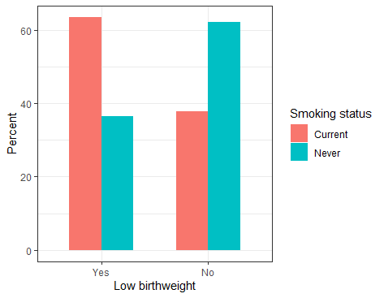
One can save labels in a separate object if you intend to use it multiple times. To suppress printing of the clustering variable title, use element_blank() or simply put fill = "".
lab1 <- labs(x = "low birthweight", y = "Percent",
fill = element_blank())

10.2.2 Stacked barchart
The second categorical (grouping) variable is indicated by fill = fct_smoke argument. By default, R produces a stacked barchart. In some instances, stacked barcharts better illustrate the key pattern.
lab1 <- labs(x = "low birthweight", y = "Percent",
fill = element_blank())
ggplot(aaa,
aes(x = fct_lowbwt, y = perc, fill = fct_smoke)) +
geom_bar(stat = "identity") + lab1
It is also useful to consider colour-blind friendly graphics and print in one colour with varying shades. Let’s print in grey as often seen in academic papers by adding scale_fill_grey() option.
stack1 <- ggplot(aaa,
aes(x = fct_lowbwt, y = perc, fill = fct_smoke)) +
geom_bar(stat = "identity") +
scale_fill_grey() + lab1

11 Save plots
To save a plot, we specify an object and file name using ggsave.
ggsave(stack1, file = "z_stackedbar_bwt_smoke.png")
## Saving 5 x 4 in image
Earlier, we used grid.arrange to arrange multiple plots. We can save these multiple graphs in one file.
g1 <- grid.arrange(d2, stack1, ncol = 2, nrow = 1)
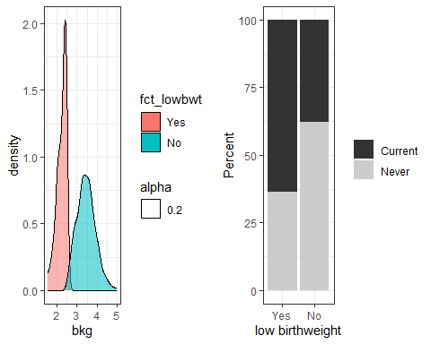
ggsave(g1, file = "z_combined_density_stackbar.png")
## Saving 5 x 4 in image

12 Your task
Please practise many times to be familiar with the ggplot syntax. Keep experimenting with the code by changing the variables and options. Determine which graph is suitable to tell your story. Example exercises are shown below.
- Inspect bkg variable and identify potential outliers and treat it appropriately.
- Pick two continuous and two categorical variables. Among these four variables, think of the combinations to depict univariate and bivariate distributions. What kind of graphs would you use? What is the major pattern you intend to reveal? Visualise the look of graphs (in your head) and edit the ggplot arguments to produce graphs.
- Examine Salaries data introduced during in-class Exercise and visualise the data.

13 Extra practice (beyond Intro ggplot)
Although we typically analyse microdata, aggregate data can be useful to illustrate the global trend as a way of setting the scene. We use OECD data to investigate the change in employment rate among chosen countries over time.

13.1 Convert character to factor variables
Let’s create a factor variable for country to be used in barcharts. Note that we factorise the country variable using levels argument (not labels as seen in Practical 2) when a variable is entered as characters.
a <- read_csv("OECD_emp_cleaned.csv")
head(a, n = 4)
cou country year sex value age agegr
<chr> <chr> <dbl> <chr> <dbl> <chr> <chr>
1 CHN China 2000 Men 82.9 TOTAL Total
2 CHN China 2010 Men 78.2 TOTAL Total
3 FRA France 1990 Men 65.5 TOTAL Total
4 FRA France 1995 Men 63.5 TOTAL Total
a$f_country <- factor(a$country,
levels = c("UK", "USA", "Germany",
"France", "Sweden", "Japan", "China"))

The contents in section 13.2 and 13.3 go beyond the learning outcomes set out in Practical 3, and go over only if time permits. Please skip the following two sub-sections as necessary. It is essential that you allocate sufficient time to grasp the concepts covered up to section 11.

13.2 Horizontal barchart using two time periods
To plot horizontal barcharts, we use coord_flip() argument.
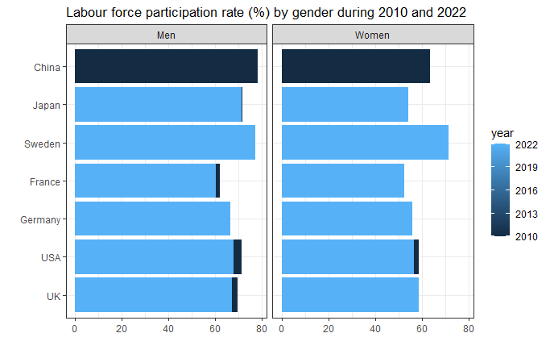
Assess the barchart and interpret it. Why would you opt for horizontal barcharts? Are there any problems? How would you improve the graph?

13.3 Line graph showing a long-term trend
Line graph is extensively used in the visualisation of longitudinal data.
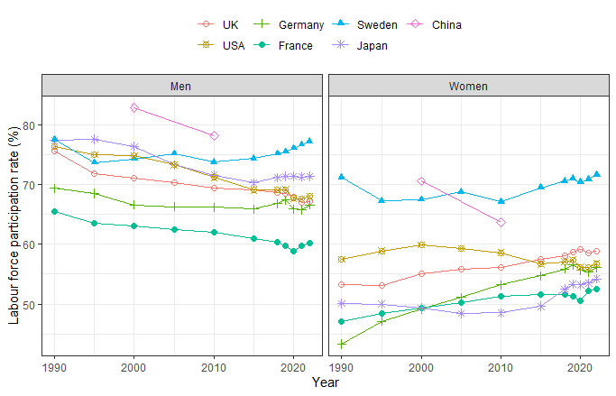
Is the graph self-explanatory? Does the graph illustrate a global long-term trend well?

